CLASS 8 | HW
HINDI | - अब तक करवाया गया सारा पाठयक्रम दोहराएं।  - अपनी अभ्यास पुस्तिका सारा कार्य लिखें  - तीन मशहूर गायकों की फोटो लगाकर उनके बारे में लिखें तथा उनके द्वारा प्रयोग में लाए जाने वाले संगीत यंत्रों की फोटो स्क्रैप बुक में लगाएं.  - कोई भी एक folk song हिन्दी भाषा में लिखें।  - कोई तीन सामुदायिक गीत (कम्यूनिटी सोंग) हिन्दी भाषा में लिखें।  - कोई भी एक भारतीय कला के मह्त्व के बारे में लिखें।
ENGLISH | 1. Make a project file and write about the poets, authors and freedom fighters of Assam.  2. Learn and write the question answer of chapters 6,7,8,9(honeydew along with poems),6,7,8 (IT SO HAPPENED)  3. Learn and write two notices (lost or found) in C. W.  4. Learn and write an application to your principal (due to sickness and due to some urgent work) in C. W.  5. Write a letter to your friend describe him how you celebrated your birthday.
MATHS | Chapter 9 : Algebraic Expressions and Identities  Ex- 9.1 : Q3,Q4  Ex- 9.2 : Q4  Ex- 9.3 : Q3,Q4,Q5  Ex- 9.4 : Q2,3(ii)(iv)(vii)  Ex- 9.5 : Q1(ii)(iii)(vii), Q2(ii)(iii)(vi), Q3(iii)(iv), Q4(ii)(iii), Q5(i)(ii)  Chapter 10: Visualising Solid Shapes  Ex- 10.1 : Q3, Q4  Ex- 10.3 : Q1,Q4,Q6,Q7,Q8  Chapter 11: Mensuration  Ex- 11.1 : Q1,Q2,Q4  Ex- 11.2 : Q2,Q3,Q5,Q7  Ex- 11.3 : Q1,Q5,Q7,Q9  Ex- 11.4 : Q3,Q5,Q6  Chapter 12: Exponents and Powers  1) Do Practice of laws of Exponents  Ex- 12.1 : Q2,Q3,Q5,Q6  Ex- 12.2 : Q1,Q2,Q4
SCIENCE | - Do all exercise questions of chapter15 (Some Natural Phenomena).  - Practice at least four CCT based Questions.  - Revise all chapters for PT2.  - Do all the activities of chapter 14 and 15.  - Complete all pending work and upload in Google class room.
SST | 1.Make ten very short answer types questions along with their answers from each chapter …  1.from ..history chapter no. 6and 7,from.. geography ch.5 and 6 and from civics ch.6 ,7,8,9 and 10(Answer should be one word or one sentence only )  2. Write in a class note book .  3.project file you can make on any topic of nature disaster and minimum should be 10 .  3. Geography5 and 6 chapters map practice do in a map and pasted on class note book.  4. Learn all chapters which have been taught after half yearly exam..
SKT | 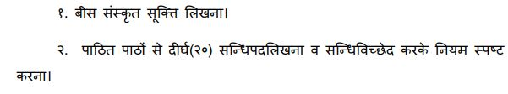  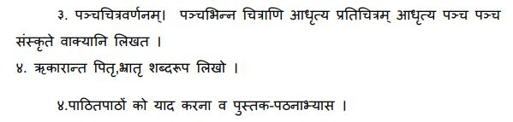
COMPUTER | Draw the flowchart for  - Find the addition of two number.  - Find whether a people eligible to give vote or not.  - Find given number even or odd.  - Find whether a people drive car or not

