Kendriya Vidyalaya no.4 Jaipur
Winter Vacation Holiday Home-work for class 5th
(From 22/12/20 to 10/01/21)
EVS
- Make a list of our helpers and write their names with pictures.
- Write few sentences on any five famous sports personality with pictures.
- Sow any seed and observe the growth of plant. Write some sentences on this process.
- Write the importance of trees. Why trees are very useful for us.
- Mark the name of states and UT in Indian map.
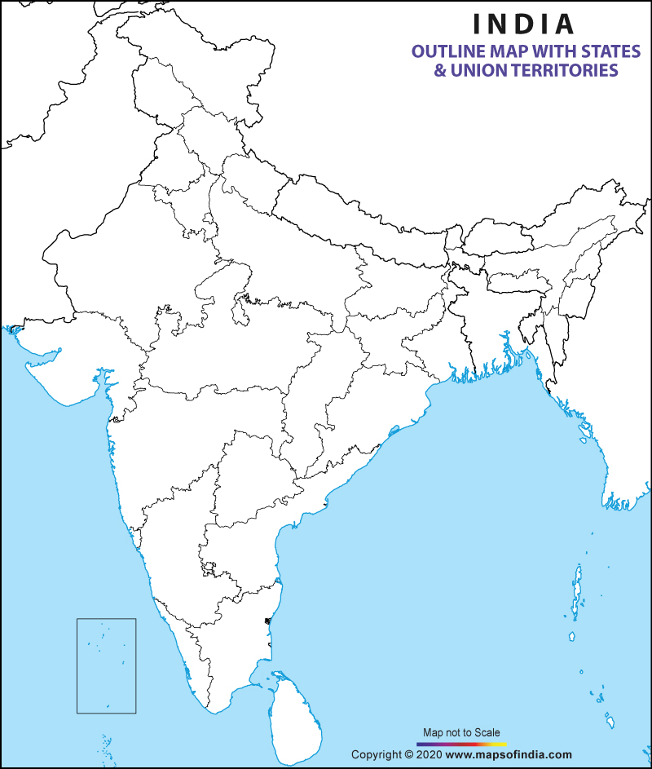

English
1 learn all the lessons as persyllabus of pt2
2Contractions
https://www.liveworksheets.com/vt1238941vl
3 Punctuation
https://www.liveworksheets.com/rd1036627yu
4 Simple present tense
Video-
https://youtu.be/UZMDp89VjEM
Worksheet
https://www.liveworksheets.com/vv410422jo
5 Suffix and prefix
https://www.liveworksheets.com/jy1242756zh
6write few lines about change in your lifestyle during corona.(CCT questions)
7 Write few lines about the things you like and dislike about the city you live in.(CCT questions)
8Conjunctions
https://www.liveworksheets.com/qq7323ke
9 Homophones
https://www.liveworksheets.com/xl41496hq
10 comparative and superlative
https://www.liveworksheets.com/id/tf173255ta

Mathematics
1. Take a 16.cm long thread. Make different shapes by joining its ends on a square-sheet. Find which shapes has the biggest area and which has the smallest.

2. Do practice of multiplication and division sums.(find different ways of multiplication)

3. Learn tables up to 20.
4. THE LENGTHS OF 5 RECTANGLES HAVE BEEN GIVEN IN THE TABLE.THE AREA OF THESE RECTANGLES ARE ALSO GIVEN IN THE BOX. MATCH THE AREAS TO ITS RESPECTIVE RECTANGLES AND COMPLETE THE TABLE.
26 | 56 | 96 | 16 | 45

SIDE A | SIDE B | AREA | PERIMETER
7m
13m
12m
15m
2m

5.On any one day, choose any 5 cities and record their temperature from the TV or newspaper and make tally marks, Pie Chart and Bar Graph in your note book.

हिंदी
- आपकी पसंदीदा कोई भी एक कहानी लिखो|
- पिछले 8-10 महीनों में हमारी दिनचर्या किस प्रकार से बदल गई हैं अपने शब्दों में लिखो|
- वर्तमान परिप्रेक्ष्य में ऑनलाइन स्टडी के पक्ष व विपक्ष में अपने तर्क दीजिए|
- कोई भी एक अपनी पसंदीदा कविता लिखो (स्वरचित) |
- अपनी पुस्तक से 10 पृष्ठ सुलेख लिखो| बहुत सुंदर व स्पष्ट होना चाहिए|
- आपके विद्यालय जीवन की कोई भी एक यादगार घटना का वर्णन करो|
- प्रार्थना पत्र– आपको अपनी बहन की शादी में जाने के लिए प्रधानाचार्य को 4 दिन के अवकाश हेतु प्रार्थना पत्र लिखो|
- आपकी पाठ्यपुस्तक की पृष्ठ संख्या 148 से 152 पर दिए गए सभी शब्दार्थों को अपनी कॉपी में लिखकर याद करें|

COMPUTER

- Create a time table of your class in word using tables.
- Create a greeting card using page borders and other options.

