ENGLISH HOME ASSIGNMENT-2021 WINTER BREAK. (CLASS VII)
- SOLVE UNSEEN PASSAGE-2
- WRITE A PARAGRAPH ON THESE TOPICS-
- A CRICKET MATCH
- A VISIT TO A ZOO
- MY BEST FRIEND
- MY HOBBY
- MY FAVOURITE BOOK

- READING LESSONS AND POEMS AND PREPARE QUESTIONS AND ANSWERS – THE EXPERT DETECTIVE, THE INVENTION OF VITA WONK, FIRE:FRIEND AND FOE, A BICYCLE IN GOOD REPAIR)
- READING NEWS PAPERS DAILY.
- JUMBLED SENTENCES-25
- WRITE OPPOSITES-25
- APPLICATION WRITING-
(I)WRITE AN APPLICATION TO YOUR PRINCIPAL REQUESTING HIM/HER TO GRANT LEAVE FOR THREE DAYS.
(II) WRITE AN APPLICATION TO YOUR PRINCIPAL REQUESTING TRANSFER CERTIFICATE.
- NOTICE WRITING-
(I)YOU ARE ROHAN/ ROMA OF KRISHNA SCHOOL JAIPUR. YOU HAVE LOST YOUR WATCH SOMEWHERE IN SCHOOL CAMPUS. WRITE A NOTICE IN 50 WORDS.
(II) YOU ARE RAKESH/ RASHMI OF JAIPUR SCHOOL. YOUR SCHOOL IS CELEBRATING ANNUAL FUNCTION. WRITE A NOTICE FOR YOUR SCHOOL NOTICE BOARD FOR CANDIDATES WHO WANT TO TAKE PART IN ANNUAL FUNCTION ACTIVITIES IN 50 WORDS.
- PROJECT WORK IN FILE IN FIVE PAGES- FIRE : CAUSE OF FIRE AND PREVENTIVE SAFETY MEASURES , CRICKET PLAYERS OF INDIA ,

शरद कालीन अवकाश गृह कार्य
कक्षा-सातवीं
वसंत भाग- 2
1. कंचा और खान -पान की बदलती तस्वीर पाठों को पढ़कर उसमें से संज्ञा, सर्वनाम और विशेषण शब्दों को छांट कर लिखें।
2. द्वंद्व समास के 10 उदाहरण लिखें।
3.कारक किसे कहते हैं? कारक के विभक्ति चिन्ह कौन-कौन से होते हैं? प्रत्येक विभक्ति चिन्ह से एक एक वाक्य बनाएं।

महाभारत
पांडवों की रक्षा, द्रौपदी स्वयंवर, इंद्रप्रस्थ ,जरासंध और शकुनि का प्रवेश पाठ पढ़ें एवं संक्षिप्त प्रश्नों का निर्माण करके उनके उत्तर लिखें।
पत्र लेखन
1.फीस माफी हेतु अपने विद्यालय के प्राचार्य को पत्र लिखें।
2.अपने छोटे भाई को समय का सदुपयोग बताते हुए पत्र लिखें।
अनुच्छेद लेखन-स्वच्छता का महत्व विषय पर अनुच्छेद लिखें।
नोट - दिया गया कार्य अवकाश गृह कार्य की कॉपी में करें ।

Autumn Break
Holiday Home Work (Science)

Class – VII
- Prepare a chart/ poster on the topic – Effect of sugar on oral health.
- Solve Half Yearly exam question paper
- Slogan writing on the topic-Effect of sugar on general health.
- Answer the following questions
1. Draw labelled diagram of the following.
(i) circulation of blood (iii) Human excretory system
(ii) Human Heart (iv) Section of a root
2. Find out about different blood group and their importance.
3. What is ECG? What is the use of it?
4. What is the role of platlets in our body?
5. Explain about the functioning of heart?

2. CLASS - VII A& B
( Subject- Social Science)

GEOGRAPHY
Chapter - Paste India's Political map in your homework notebook and mark 28 States and 8 union territories and also learn.
- Paste world map from 'Water' chapter and marked Ocean Currents in it and also learn.
CIVICS
Chapter - write and learn glossary of following chapter in your homework note book.
1. How the state government works.
2. Growing up as boys and girls.
3. Women change the world.
HISTORY
- write and learn sequence of Mughal kings in your homework notebook.

- What is the meaning of these terms
1. Manasabdars
2. Iqta
3. Sulh-i-kul

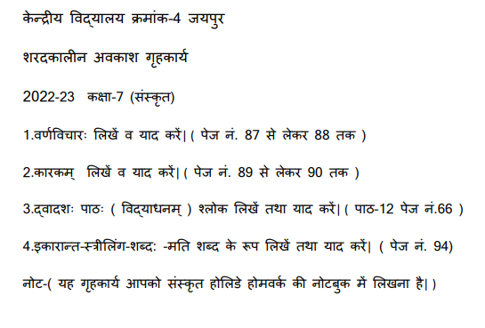
COMPUTER HOLIDAY HOMEWORK
CLASS 7 A & C
- WRITE THE HTML CODE FOR CREATING A WEBPAGE WITH THE BACKGROUND COLOR ‘GREEN AND THE TEXT COLOR ‘RED’.

CLASS 7 B
- WRITE ANY 8 HTML TAGS AND THEIR DESCRIPTION.

