**ENGLISH**

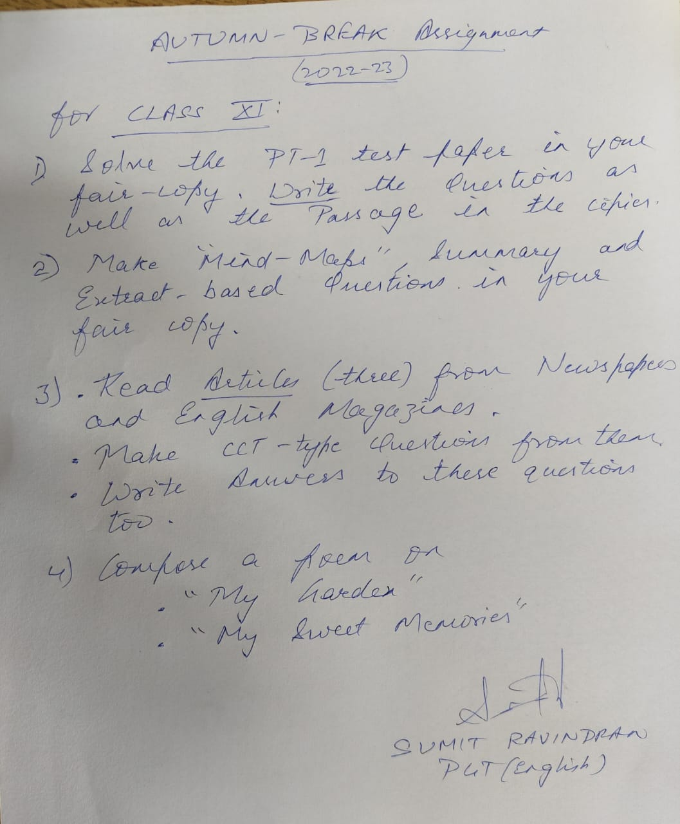

**शरद कालीन अवकाश गृहकार्य**

**कक्षा :ग्यारहवीं**

**विषय :हिन्दी**

1. दो औपचारिक एवं दो अनौपचारिक पत्र लिखें |

2.तीन रचनात्मक लेख लिखें |

3.भारतीय गायिकाओं में बेजोड़ :लता मंगेशकर एवं राजस्थान की रजत बूंदे पाठ से 50-50 बहुविकल्पीय प्रश्नोत्तर करें |

4.प्रथम आवधिक परीक्षा के वर्णनात्मक प्रश्नों को हल करें | 5.पढ़ाए गए पाठ एवं कविताओं का कार्य पूर्ण कर पुनरावर्ति करें |

**CLASS XI B PHYSICS**

**To learn chapters Dimensional analysis , motion in one dimension , motion in 2 dimension .**

**A test will be given on 14th of October on chapters Dimensional analysis , motion in one dimension**

**And on 21th of October on chapter motion in 2 dimension.**

**Prepare a science magazine for te month of September that includes**

**Recent news related to science , Recent discoveries in science , biography of one scientist.**

**KENDRIYA VIDYALAYA NO. 4 JAIPUR**

AUTUMN BREAK HOLIDAY HOMEWORK

CLASS 12 SUB: CHEMISTRY

**Q.1 Proper work on NCSC 2022-23 project**

**Q2. Proper solution of PT-1 exam 2022-23 in your notebook**

**Q3. Reading of chapter. AMINES, & prepare notes of chapter biomolecules**

**Q4. Complete the exercise of chapter which is completed.**  
Q5. Give the structures of A, B, and C in the following reactions:Class 12 Chemistry Important Questions Chapter 13 Amines 6Class 12 Chemistry Important Questions Chapter 13 Amines 8 **Q5.**What happens when bromine attacks CH2 = CH – CH2 -C ≡ CH?  
 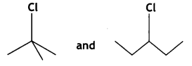

Q6. Identify the chiral molecule in the following pair

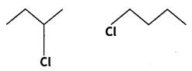

Q7.Write the structure of the product formed when chlorobenzene is treated with methyl chloride in the presence of sodium metal and dry ether

Q.8Why is chloroform kept in dark coloured bottles?

Q9.Which alkyl halide from the following pair Is chiral and undergoes a faster SN2 reaction? 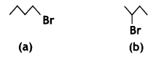  
Q10. Draw the structure and name the product formed if the following alcohols are oxidised. Assume that an excess of the oxidising agent is used. Class 12 Chemistry Important Questions Chapter 11 Alcohols, Phenols and Ethers 53

KENDRIYA VIDYALAYA NO 4 JAIPUR

HOLIDAYS H W AUTUMN BREAK 2022-23

CLASS – XI B BIOLOGY

1. Solve question paper of PT-1 in notebook.
2. Read chapters 6,7,8 and write the difficult words in note book.
3. Complete the notes and exercises of chapters 1 to 5 in note-book, if it is incomplete.
4. Make 5 MCQs from chapters 5,6,7 (total 15 questions).
5. Make an Investigatory project on a topic of your choice from biology and submit on 13/10/2022.
6. Make a project for participate in NCSC / Science exhibition to be held after break.

AUTUMN BREAK HOLIDAY HOME WORK

CLASS XIA, C SUB: - ECONOMICS

1. Complete your pending notes.
2. Paste the question paper of PT-1 in note book and solve it.
3. Practical file:- prepare investigatory project on any topic related to micro economics.
4. Solve one numerical and diagrammatically question on frequency, geometric and line graphs.
5. Write down formulas of measures of central tendency. (mean , median and mode)

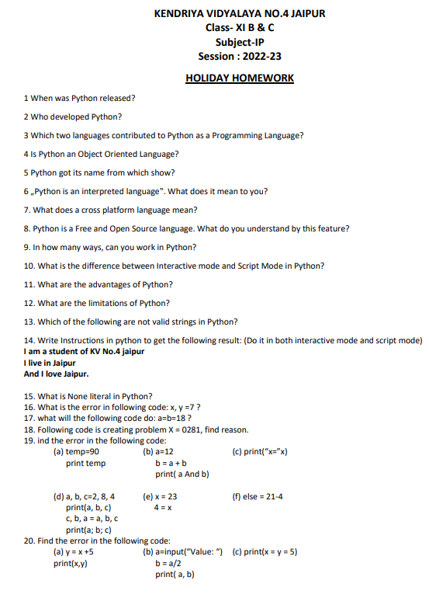

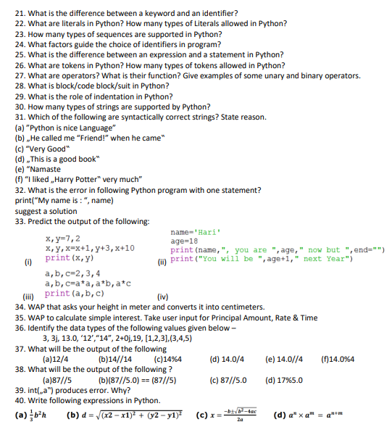

**KENDRIYA VIDYALAYA NO.4 JAIPUR**

**AUTUMN BREAK (2022-23) HOMEWORK**

**CLASS: XI SUBJECT : MATHEMATICS**

**INSTRUCTIONS: Do all these questions in a separate file (A-4 sheets)**

**SETS**

1. Write down all possible subsets of sets {1,2}
2. Write down all possible subsets of sets {a,b,{c}}
3. Write number proper subset of a set having six elements.

**Write the following sets in set builder form** (Question 5 to Question 8)

1. A={5,10,15,20,25}
2. B={5,25,125,625,3125}
3. C={2,5,10,17,26}
4. D={1/2 ,2/3,3/4,4/5,5/6}
5. E={1/2, 2/5, 3/10, 4/17,5/26}

**Write the following sets in roaster form**(Question 10 to Question 12)

1. A={x: xєz,x2<25}
2. B={x:x is a letter of the word “principal”}
3. C={x:x is a two digit natural number such that sum of its digit is 8}
4. D ={x:x is a natural number and divisor of 36}
5. For A = {1, 2, 3, 4, 5, 6}; B = {3, 4, 5, 6}, C = {4, 5, 7, 8} and U = {1, 2, ----------,8}

Find (a) (A – B) / , (b) 

1. For A = {1, 2, 3, 4, 5, 6}; B = {3, 4, 5, 6}, C = {4, 5, 7, 8} and U = {1, 2, ----------,8}

Verify that (1) ;

(2) 

1. For A = {1, 2, 3, 4, 5, 6}; B = {3, 4, 5, 6}, C = {4, 5, 7, 8} and U = {1, 2, ----------,8}

Verify that (1) A- (B) = (A- B) (A - C)

(2) A(B- C) = (AB)- (AC)

16. A and B are two sets such that n (A) = 3 and n (B) = 6

Find (1) minimum value of n () (2) maximum value of n ().

17. Let A,B and C be 3 sets such that AUB=AUC and = show B=C.

18. If  show that (C-(C-A)

19. If  and BЄC,is it true that AЄC, Explain giving example.

20. Find AUB and  if A={x : xЄz and x2 <=36},B={x : x is a prime natural number whose square is <50}

**RELATIONS AND FUNCTIONS**

1. If , and verify that
2. =  (ii) = 
3. If , and find 
4. If , and , find 
5. A = {1,0,-1}, B={2,3}, C={1,-1}, find A × B × C and B × A × C
6. If (a,1), (b, -1) and (c, c) are three elements of A × B and n(B×A) = 9, Find the sets A,

B and B×C. Ans {a,b,c},{1,-1,c},{ (a,1), (a,-1), (a,c), (b,1), (b,-1), (b,c), (c,1), (c,-1), (c,c)}

1. 7.If , then find 
2. Let Define a relation *R* on set *A*, . Write ,

represent  using arrow diagram and also write domain and range of .

1. is defined by, . Find , , 
2. Find the domain and range of function given by 
3. **Find domain and range of following functions**:

a)  b)  c)  d) 

e)  f)

**TRIGONOMETRY CLASS XI**

1. Evaluate

(i) Cos (- 480 0) (ii) Sin (- 1125 0) (iii) cot (690 0) (iv) Sin ( - 765 0)

(v) Cos 120 0

2) (i) Show that *Cos 510. Cos 330 + Sin 390. Cos 120 = -1*

(ii) Show that *Sin (-420) Cos 390 + Cos (-660) Sin 330 = -1*

1. Evaluate *cot ( 90 + x)+ tan ( 180 + x) + sec (360 – x) + cosec ( 270 – x)*

4) If *A - B =∏ /4 ,* Show that *( 1+ tan A) ( 1+ tan B ) = 2 tan A*

5) If *tan (A + B) = x* and *tan ( A – B) = y*, then Find *tan 2A*

6) Show that *tan 8θ – tan 6θ – tan 2θ = tan 8θ. tan 6θ. tan 2θ*

7) Show that *cot 3x.cot4x - cot7x.cot3x - cot7x.cot4x = 1*

8) Show that Cos200 Cos 400 Cos 600 Cos 800 = 1 /16

9) Show that Sin 200 Sin 400 Sin 600 Sin 800 = 3/16

10) If *A + B = ∏ /4* , Show that *( 1+ tan A) ( 1+ tan B ) = 2*

**COMPLEX NUMBERS**

1. i49 + i 68 + i89 + i110
2. i37 + i-67
3. 1 + i10 + i20 + i30
4. 2 i2 + 6 i3 + 3i16 – 6 i19 + 4 i 25 + 4
5. Show that in + i n + 1 + i n+2+ i n + 3 = 0
6. Show that (- i) 4 n + 3 = i

Express in standard form

1. 
2. 
3. 
4. 
5. Find x and y in the following case
6. x + (2x – 3 y ) i = 6 + 3 i
7. Find x and y in the following case
8. (x+ i).(x + iy) = 2 - 5i
9. Find x and y in the following case



1. **Find the conjugate and the modulus of the followings**

a) (3 - 2i).(3 + 2i)(1 + i) b) (2 + 3 i)2

16) If conjugate of is , find 

17) If conjugate of is , find 

18) If , find *a* and *b*

19) Find the least value of n if 

20) If z1= 2 +3i and z 2 = - 1 + 3i, then find Im

**LINEAR INEQUALITIES**

**Solve for x from Q No 1 to 9**

$\frac{3\left( x – 2\right)}{5} ≤ \frac{5\left(2 –x\right)}{3}$

1. 2 (2*x*+ 3) – 10 < 6 (*x*– 2)
2. 3 (2 –*x*)≥2 (1 –*x*)
3. 37 – (3*x*+ 5)>9*x*– 8 (*x*– 3)
$\frac{5-2x}{3} ≤ \frac{x}{6}-5$

5. –3 $≤$–3x + 2 < 4,
$\frac{\left(2x-1\right)}{3}≥\frac{\left(3x-2\right)}{4}-\frac{\left(2-x\right)}{5}$

$\frac{x}{4}<\frac{\left(5x-2\right)}{3}-\frac{\left(7x-3\right)}{5}$

7. Solve the system of inequalities

3*x* – 7 < 5 + *x and* 11 – 5 *x* ≤ 1 and represent the solutions on the number line

1. A manufacturer has 600 litres of a 12% solution of acid. How many litresof a 30% acid solution must be added to it so that acid content in the resulting mixture will be more than 15% but less than 18%?

**KENDRIYA VIDYALAYA NO. 4 JAIPUR**

**AUTUMN BREAK HOME WORK**

**CLASS: XI COMMERCE SUBJECT: ACCOUNTANCY**

**1. Complete all the pending theoretical notes.**

**2. Paste the question paper of P.T. – 1 in note book and solve it.**

**3. Practical file:**

**(a) Accounting Principles:**

**Going Concern, Business Entity, Historical Cost,**

**Dual Aspect, Revenue Recognition and Matching Concept.**

**(b) Any 3 questions from the chapter – Accounting Equation.**

**(c) One numerical containing 10 to 12 business transactions – Pass Journal entries.**

**KENDRIYA VIDYALAYA NO. 4 JAIPUR**

**AUTUMN BREAK HOME WORK**

**CLASS: XI COMMERCE SUBJECT: BUSINESS STUDIES**

**1. Complete all the pending theoretical notes.**

**2. Paste the question paper of P.T. – 1 in note book and solve it.**

**3. Case Based Questions**

**Chapter – 1**

**Three questions (3 or 4 marks)**

**Three questions (5 or 6 marks)**

**Any Ten Objective type questions (MCQs, fill in the balnks, True/False etc.**

**Chapter – 2**

**Three questions (3 or 4 marks)**

**Three questions (5 or 6 marks)**

**Any Ten Objective type questions (MCQs, fill in the balnks, True/False etc.**

**4. Project File:**

**Prepare a Project on any Indian Business Organization Like – Amul, Saras, HUL, Tata Motors etc.**

Class -11A POLITICAL SCIENCE

Paste India's Political map in your homework notebook and mark 28 States and 8 union territories in your homework notebook.

- Make 20-20 MCQ question from following chapters and write in your notebook -

1. Constitution at work

2. Election and representation

3. Political Theory-Introduction