ENGLISH HOME ASSIGNMENT-2022 AUTUMN BREAK

CLASS X
- SOLVE UNSEEN PASSAGE-3
- ARTICLE WRITING IN GOOD HAND WRITING- ( 1 CLEAN INDIA CAMPAIGN, 2 BOOKS- OUR BEST COMPANION, 3 INDIA’S PROGRESS AFTER INDEPENDENCE, 4. SAVE ENVIRONMENT IS ESSENTIAL FOR OUR LIFE, 5. WOMEN EDUCATION)
- READING LESSONS AND POEMS AND PREPARE QUESTIONS AND ANSWERS–GLIMPSES OF INDIA, MIJBIL THE OTTER, MADAM RIDES THE BUS, THE MAKING OF A SCIENTIST, THE NECKLACE, BHOLI
- READING NEWS PAPERS DAILY.
- LETTER WRITING
(I) WRITE A LETTER TO THE EDITOR OF A NEWSPAPER, HIGHLIGHTING THE IMPORTANCE OF GAMES AND SPORTS IN OUR LIFE.
(II) WRITE A LETTER TO THE EDITOR TO PUBLISH THE IMPORTANCE OF COMPUTER IN EDUCATION.
- PROJECT WORK IN FILE IN TEN-FIFTEEN PAGES -1 TOURIST PLACES OF INDIA ( BROCHURE), GAUTAM BUDDHA LIFE SKETCH.

शरद कालीन अवकाश गृह कार्य
कक्षा- दसवीं
- संज्ञा ,सर्वनाम, विशेषण एवंक्रिया के प्रत्येक भेद के दो -दो उदाहरण लिखें।
- उत्प्रेक्षा अलंकार ,मानवीकरण अलंकार ,अतिशयोक्ति अलंकार और श्लेष अलंकार प्रत्येक के दो दो उदाहरण लिखें एवं याद करें।
3. सरल वाक्य ,संयुक्त वाक्य एवं मिश्र वाक्य के दो- दो उदाहरण लिखें।
4. शिक्षक पद के आवेदन के लिए एक स्ववृत लिखें।
5. परियोजना कार्य के अंतर्गत पोर्टफोलियो बनाए।
6. अक्टूबर में होने वाली मासिक परीक्षा में आने वाले सभी पाठों को याद करें |

नोट - दिया गया कार्य अवकाश गृह कार्य की कॉपी में करें ।

Autumn Break
Holiday Home Work (Science)
Class – X
- Complete your Practical record book.
- Complete project work.(management of natural resources)
- Revise the chapters for Monthly Test-3 (To be held in Oct.)
- Reproduction in Humans
- Control and coordination
- Carbon and its compounds
- Our environment
- Write and learn answer of the following questions-
1. what is an homologous series? Explain with an example.
2. Explain the mechanism of cleansing action of soap.
3.What is hydrogenation ? What is its industrial application?
4.Draw the structures of the following compounds
(i) Ethanoic acid (b) Bromopentane
(c) butanone (iv) hexanal
5. write the phenotype and genotype ratio of monohybrid and di-hybrid cross.
6. How is the sex of the child determined in human beings?
7. What are the different methods of contraception?
8. What is 10 % law? Explain with an example?
9. What is biological magnification?
10. What are trophic levels? Give an example of a food chain and state the different trophic levels?

Autumn Break Holiday Homework
Class X Subject-Mathematics

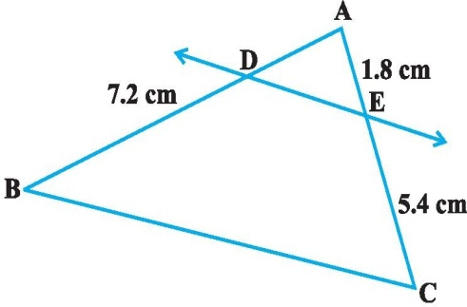
- The roots of the equation x² + 7x + 12 =0 are
(a) 3 and 4 (b) –3 and 4 (c) –3 and –4 (d) 3 and –4

2. If p – 1, p + 3, 3p – 1 are in AP, then p is equal to
(a) -4 (b) 4 (c) 8 (d) – 8

In figure DE || BC then the value of AD is
  - 2.4 cm (b) 2.0 cm (c) 3 cm (d) none of the above

- What is the midpoint of a line with endpoints ( 3, 7) and (11, –5)?
(a) (7, –1) (b) (14, –2) (c) (7, 1) (d) none of these

- Find the point on x-axis which is equidistant from (2, -5) and (-2, 9 ).
- In the below figure, DE || BC, find EC
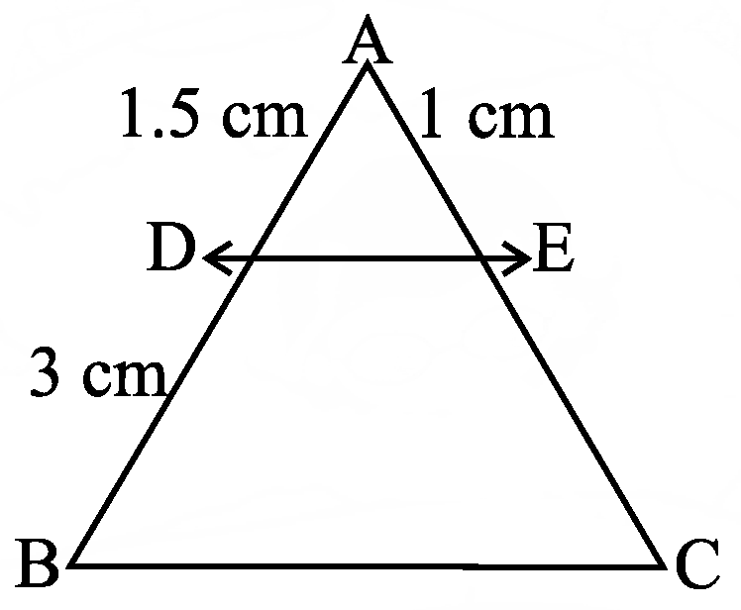

- Which term of the AP : 3, 8, 13, 18, ,is 78?
- Find the value of k for which the quadratic equation 9x² + 8kx + 16 = 0 has two real equal roots

- Solve by using quadratic formula
- + 3x – x² = 0
- (I)How many terms of the AP : 24, 21, 18, . . . must be taken so that their sum is 78?

(II)Find the sum of first 24 terms whose nth term is given by a_{n} = 3 + 2n.

- A point P lies on line segment joining the point A(-4,3)and B(5,-2) IF $\frac{PB}{AB}$ = $\frac{2}{5}$ find the coordinate of P

- State and prove basic proportionality theorem
- Solve for x: $\frac{1}{a}$ + $\frac{1}{b}$ +$\frac{1}{x}$ =$\frac{1}{a+b+x}$.
- CASE STUDY 1:

India is competitive manufacturing location due to the low cost of manpower and strong technical and engineering capabilities contributing to higher quality production runs. The production of TV sets in a factory increases uniformly by a fixed number every year. It produced 16000 sets in 6th year and 22600 in 9th year.
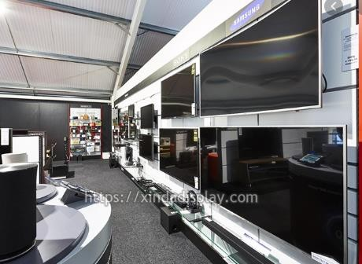

Based on the above information, answer any four following questions:

  - What will be the production during first year.
  - a. 2000 b. 2200 c. 2400 d. none of these
  - What will production during 8th year.
  - a. 18200 b. 20600 c 20400 d. none of these
  - What will the production during 3rd years.
  - a. 9400 b. 2200 c. 11600 d . none of these

  - In which year, the production is Rs 29,200.
  - a. 10 b. 11 c. 12 d. none of these
  - Find the difference of the production during 7th year and 4th year.
  - a. 4400 b. 6600 c. 6000 d. none of these

- CASE STUDY 2:

Raj and Ajay are very close friends. Both the families decide to go to Ranikhet by their own cars. Raj’s car travels at a speed of x km/h while Ajay’s car travels 5 km/h faster than Raj’s car. Raj took 4 hours more than Ajay to complete the journey of 400 km.

Based on the above information, answer any four following questions:

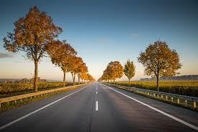
- What will be the distance covered by Ajay’s car in two hours?
- 2(x +5)km
- (x – 5)km
c) 2( x + 10)km
d) (2x + 5)km
- Which of the following quadratic equation describe the speed of Raj’s car? a) x² - 5 x - 500 = 0
b) x² + 4x - 400 = 0
c) x² + 5x - 500 = 0
d) x² - 4x + 400 = 0
- What is the speed of Raj’s car?
- 20 km/hour
- 15 km/hour
- 25 km/hour
- 10 km/hour
- How much time took Ajay to travel 400 km?
- 20 hour
- 40 hour
- 25 hour
- 16 hour
- How much time took Raj to travel 400 km?
- 20 hour
- 40 hour
- 25 hour
- 16 hour

CLASS 10 th SST.

1 . Solve the sample paper issued by CBSE in your notebook.
2. Do map practice and paste all maps in your notebook, ( map items list issued by CBSE )
3 Prepare any one project on the following topics :-
- Consumer Awareness
- Social Issues
- Sustainable Development
4 Read properly and make notes of following lessons:-
- Political Parties
- Print Culture and Modern world

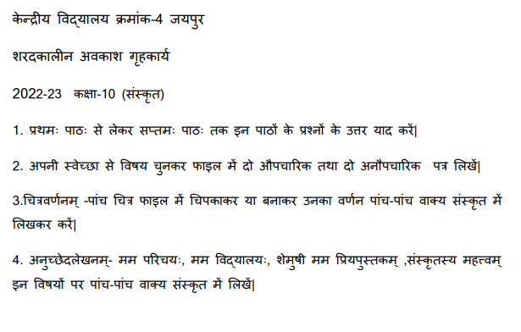
ARTIFICIAL INTELLIGENCE

MAKE A PRACTICAL FILE AND WRITE THESE PROGRAMS IN SHEETS. LAB ACTIVITY AND PROGRAM CODE ON LINED PAGE AND THEIR OTPUT ON WHITE PAGE.

LAB ACTIVITY-1
Python Program to Print Hello World

Source Code

print(“Hello World”)

Output
Hello World

LAB ACTIVITY-2
Write a program to display the name and address of your school or home using-
(i) Multiple print statement
(ii) Single print statement'''

Source Code
(i)
print("Kendriya Vidyalaya No.4")
print("Khatipura Road")
print("Near Hasanpura")
print("Jaipur-12")'''

(ii)
print("Kendriya Vidyalaya No.4\nKhatipura Road\nNear Hasanpura\nJaipur-12")

Output
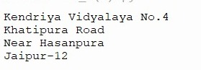
LAB ACTIVITY-3
Write a program to add two numbers using
(i) Without using Variable
(ii) Using variable
(iii) Using variable from user input

Source Code
(i)
print(45+44)

(ii)
First_val=56
Second_val=21
sum= First_val + Second_val
print(sum)

(iii)
x= int(input("Enter values of x ="))
y= int(input("Enter values of y ="))
add=x+y
print("x+y= ", add)
Output
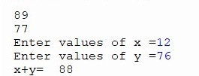

LAB ACTIVITY-4
Python Program to Calculate the Area of a Triangle

Source Code

a=5

b=6

c=7

s=(a+b+c)/2

area=(s*(s-a)*(s-b)*(s-c))**0.5

print(“The area of the triangle is %0.2f” %area)

Output
The area of the triangle is 14.70

LAB ACTIVITY-5
Python Program to Swap Two Variables

Source Code
x=5
y=10
temp=x
x=y
y=temp
print(‘The value of x after swapping: {}’.format(x))
print(‘The value of y after swapping: {}’.format(y))
Output
The value of x after swapping: 10
The value of y after swapping: 5

LAB ACTIVITY-6
Python Program to Check if a Number is Odd or Even

Source Code

num=int(input(“Enter a number: “))

if(num % 2) ==0:

print(“{0} is Even”.format(num))

else:

print(“{0} is Odd”.format(num))

Output 1
Enter a number: 43
43 is Odd
Output 2
Enter a number: 18
18 is Even

